# Guide to Setting up the System

## Running the program

1. Install Microsoft SQL Server Management Studio and connect to a server
2. After installing the project, open Visual Studio and go on ‘appsettings.json’ where one is able to change the connection string to match the same path that was set on the database from SSMS.



Figure : appsettings.json change server name

1. Go to ‘AllocationController.cs’ and change the ‘**serverName**’ variable marked with a comment towards the top of the document. This will allow for the executed join queries to be run with a connection to the local MSSQL server.



Figure : AllocationController change serverName variable

## Setting up test data

For testing purposes, it is necessary to restore from the provided backup file (*fypallocation.bak*) as a means of populating the database with readily set students, supervisors, preferences and areas. The steps to do so are as follows:

**Important:** This is to be done before executing the program, as the code first automatic database creation may prevent the restoration of the provided backup file.

1. On Microsoft SQL Server Management Studio, right click the database option.
2. Click the ‘Restore Database’ option

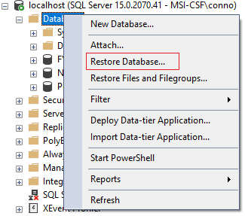

Figure : Restore Database option in right click menu

1. Enter the name ‘fypallocation’ into the destination text box highlighted

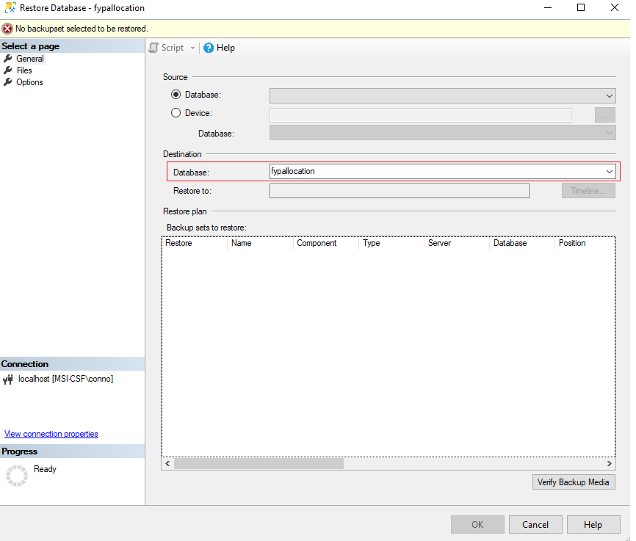

Figure : Insert name fypallocation into text box

1. Select the device option, followed by the button containing three dots.

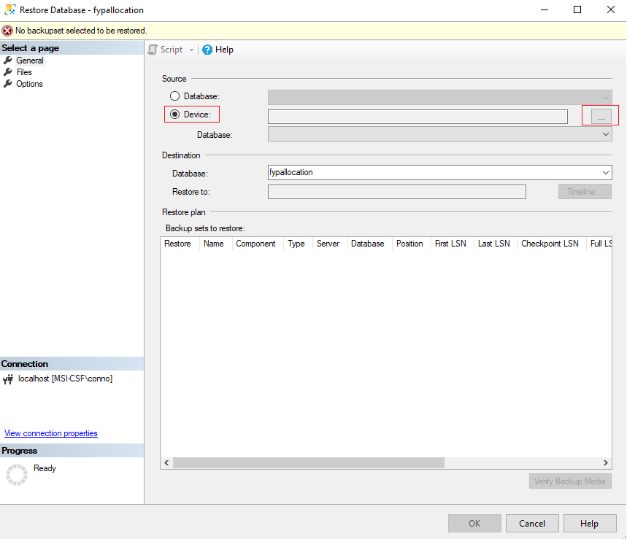

Figure : Device option, followed by button with three dots

1. After having selected the button with three dots, select the ‘Add’ button in order to specify a file path.

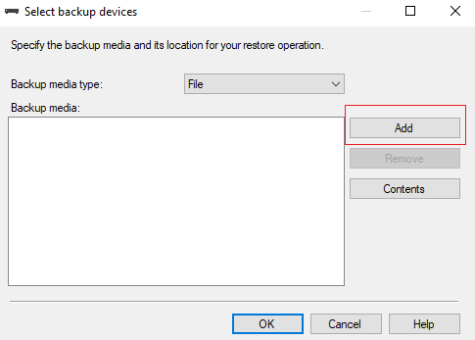

Figure : Select Add button

1. Locate the backup at the path CIS2107/GAPT/Database Backup

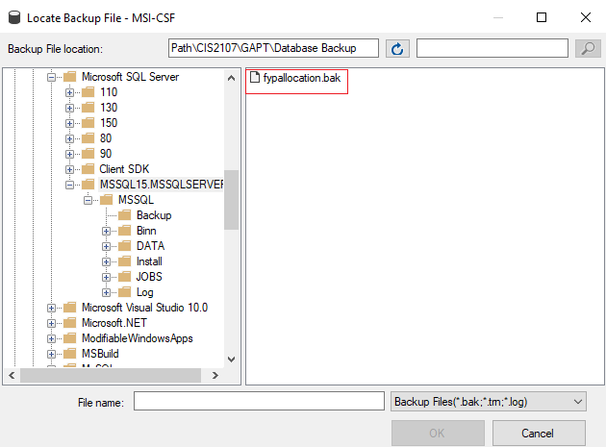

Figure : Find backup file at specified path

1. Once file is added, select ok , followed by ok in the select ‘Select backup devices’ dialogue box.

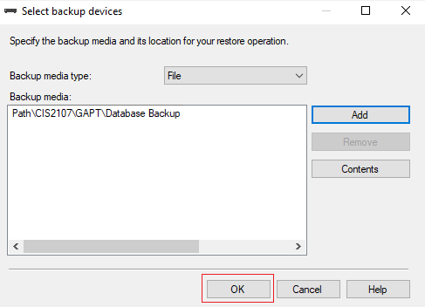

Figure : Select ok to finish device selection

1. Select ok to complete backup process

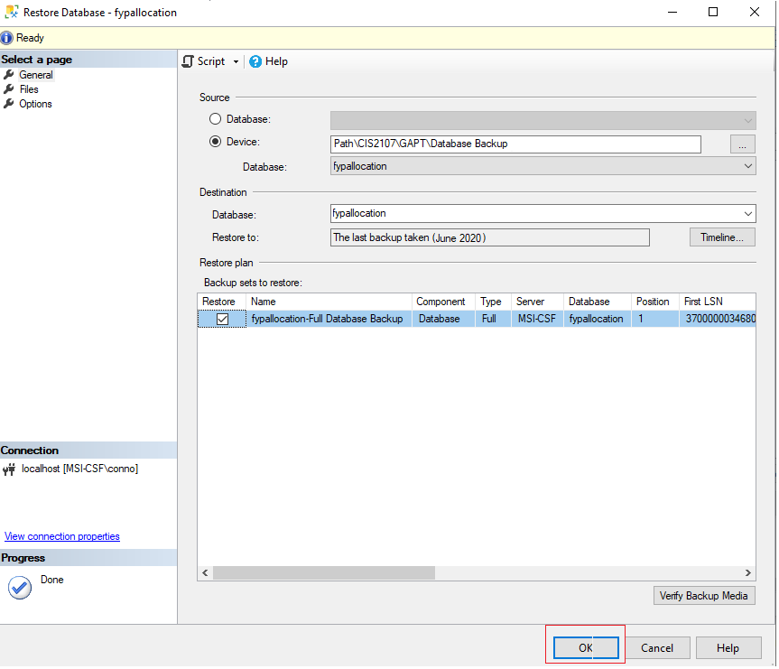

Figure : Complete backup process

1. Database backup with entire schema and test data has been successfully restored.

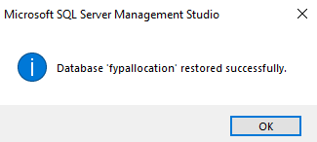

Figure : Backup process complete